VySkan
Product Name | 4G AI Video Telematics Dashcam
Product Model | VC-4CH
Intelligent. Comprehensive. Compliant.
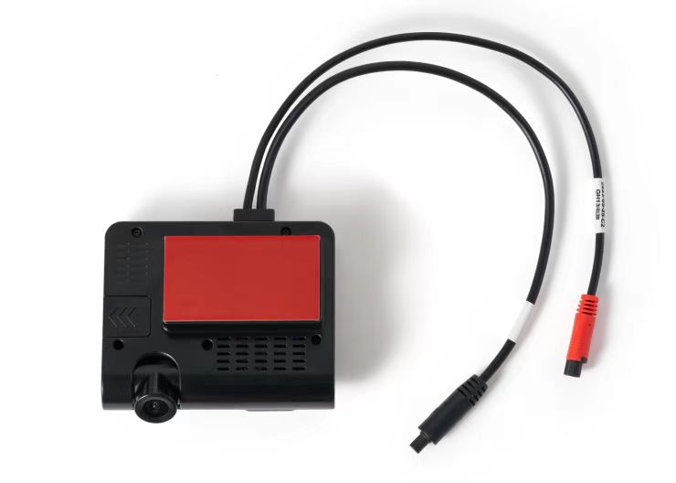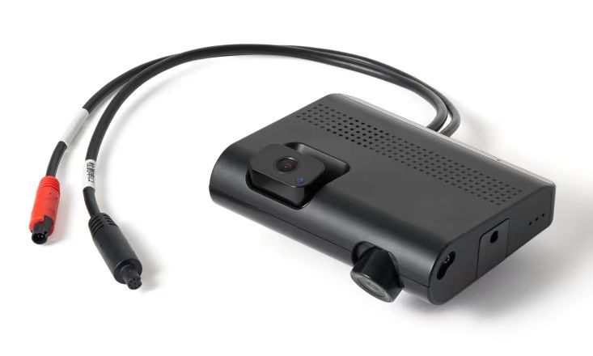
The VC-4CH is a specialized 4G smart video terminal engineered specifically for government-regulated sectors such as the ride-hailing and taxi industries. Integrating GPS positioning, 4G communication, and multi-channel video storage, it provides fleet managers with real-time remote visibility and advanced AI-driven proactive safety features.

- Core Value
- Multi-Channel HD Surveillance
Supports one 1080P main channel and up to three 720P expansion channels for comprehensive interior and exterior monitoring.
- Active Safety Algorithms
Designed with advanced driving assistance systems (ADAS) and driver status monitoring (DSM) to proactively detect and warn against risky driving behaviors.
- Real-Time Fleet Control
Enables remote real-time positioning, trajectory playback, and live video streaming. It also supports two-way voice intercom and remote audio monitoring.
- Fail-Safe Evidence Protection
Features collision locking and automatic FTP server upload for emergency video files, ensuring critical evidence is never lost.
- High-Capacity Dual Storage
Equipped with 8GB EMMC internal memory and supports dual high-speed TF cards (Class 10, up to 128GB each) for extended loop recording.

- Target Applications
- Ride-Hailing & Taxis: Built for compliance with regulated industries, supporting external peripherals like taximeters and evaluation screens.
- Commercial Fleets: Utilizes 10V-36V wide voltage and optional RS232/IO detection for deep vehicle integration.
- Technical Specifications
3.1 System & Connectivity
Category | Specification | Description
Network | 4G Full Netcom | Built-in antenna for robust data transmission.
GNSS | GPS + BD | Built-in ceramic antenna with <10m positioning error.
Wi-Fi | 2.4GHz | Built-in antenna for local configuration.
Memory | 1Gb DDR4 / 8GB EMMC | High-speed processing and internal storage.

3.2 Video & Audio
Category | Specification | Description
Main Camera (ADAS) | 1080P Full Color | Focal length 3.6MM, F2.0 aperture, 60°H field of view.
In-Cabin Camera (Optional) | 720P Auto Color-to-Black | Focal length 2.8MM, F2.0 aperture, 115°D field of view.
DMS Camera (Optional) | 720P B&W | Focal length 6MM, F2.0 aperture, 45°H field of view.
Cargo Camera (Optional) | 720P B&W | Focal length 2.8MM, F2.0 aperture, 115°D field of view.
Encoding | H.264 (Video) / G711A (Audio) | Efficient data compression formats.

3.3 Power & Physical Interfaces
Category | Specification | Description
Working Voltage | DC 10V - 36V | Compatible with various commercial vehicle power systems.
Working Current | 420mA@12V / 240mA@24V | Unloaded standard operating current.
Backup Battery | 3.7V 2000mAh | Lithium Nickel Cobalt Manganese battery for emergency power.
Sensors & Alarms | 3-axis G-sensor / SOS Button | Detects collisions and allows one-key emergency alerts.
3.4 Environmental Parameters
Category | Specification
Dimensions | L110mm × W70mm × H28mm (Without sliding cover)
Working Temp | -20℃ to +60℃
Storage Temp | -30℃ to +80℃
- Built for Rapid Integration & Deployment
- Flexible Peripheral Support: Equipped with optional RS232 serial ports and IO detection capabilities , enabling seamless integration with industry-specific peripherals like taximeters, passenger evaluation screens, and advertising displays.
- Efficient Remote Configuration: Designed for quick fleet deployment. Technicians can rapidly configure server IP, port, and APN parameters via simple SMS commands to get devices online instantly.
- Seamless Maintenance: Supports Over-The-Air (OTA) remote firmware upgrades as well as local TF card upgrades, significantly reducing after-sales maintenance costs for fleet operators.
- A personalized service prepared for you
- 1× VC-4CH Sample Device (Pre-configured)
- Full API & Protocol Documentation for Platform Integration
- 1-on-1 Technical Support from our Field Engineers
- Contact us
Website：https://vyskan.com/
Email: marketing@vyskan.com

